**Fundamentals of Cloud Computing**

1. **Understanding Cloud Computing**

**Use of remote servers rather than local or Personal Computer**

**Eg : Compute, Storage, Database, Network.**

1. Service Module of Cloud
2. IAAS (Infrastructure as a Service)
3. PAAS (Platform as a Service)
4. SAAS (Software as a Service)

* **Understanding Service Modules of Cloud Computing**
* **IAAS (Infrastructure As A Service)**
* **It is a service module that delivers computer infrastructure (Servers, Storage, Processor) on an outsourced basis to support enterprise operations.**
* **PAAS (Platform As A Service)**
* **It is a services module that provides a platform allows to develop, run, and manage applications without the complexity of building and maintaining the infrastructure.**
* **SAAS (Software As A service)**
* **It is a Service module that allows users to connect and use cloud-based apps over the Internet.**
* **WAAS (Windows As A Service)**
* **It is a service module which allows to use all windows features in Windows 10 Client OS.**
* **DAAS (Directory As A Service)**

**It is a service module in Microsoft Azure to provide Directory Services in Many ways.**

**Diagram for Service module of Cloud**

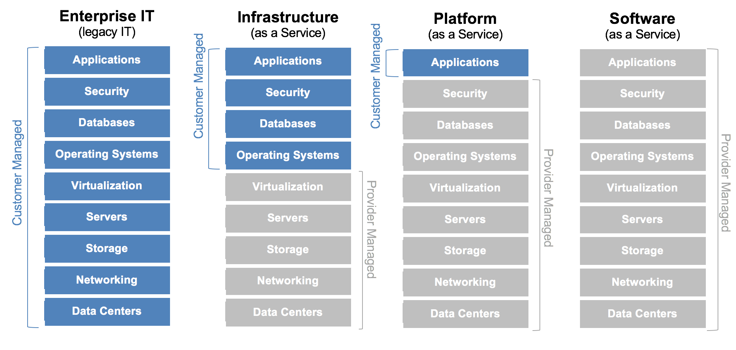

1. **Types of Cloud**
2. **Public**
3. **Private**
4. **Hybrid**

**Private Cloud**

**The private cloud is defined as computing services offered either over the Internet or a private internal network and only to select users instead of the general public.**

**Diagram for Private Cloud**



Private Cloud

**Advantages of a private clouds:**

* More flexibility—your organisation can customise its cloud environment to meet specific business needs.
* Improved security—resources are not shared with others, so higher levels of control and security are possible.
* High scalability—private clouds still afford the scalability and efficiency of a public cloud.

**Public Cloud**

**The public cloud is defined as computing services offered by third-party providers over the public Internet, making them available to anyone who wants to use or purchase them.**

**Diagram for Public Cloud**



Public Cloud

**Advantages of public clouds:**

* Lower costs—no need to purchase hardware or software and you pay only for the service you use.
* No maintenance—your service provider provides the maintenance.
* Near-unlimited scalability—on-demand resources are available to meet your business needs.
* High reliability—a vast network of servers ensures against failure.

**Hybrid Cloud**

**A hybrid cloud is a computing environment which combines a public cloud and a private cloud by allowing data and applications to be shared between them.**

**Diagram for Public Cloud**



Hybrid Cloud

* **Advantages of Cloud Computing**
* **Variable vs Capital Expense**
* **Instead of having to invest heavily in data centers and servers before knowing how you are going to use them, you can pay only when you consume computing resources and pay only for how much you consume.**
* **Economies of Scale**
* **Organizations benefit from massive economies of scale by using cloud computing we can achieve a lower variable cost that you would get on you own.**
* **Stop Guessing Capacity**
* **Organizations can access as much or as little as they need and scale up or down as required with only a few minutes notice.**
* **Increase Speed and Agility**
* **It allows organizations to reduce the time it takes to make those resources available to developers from weeks to just minutes. The cost and time it takes to experiment and develop is significantly lower.**
* **Focus on Business Differentiators**
* **It allows organizations to focus on their business priorities, instead of on the heavy lifting of racking, stacking and powering servers.**
* **Go Global in Minutes**
* **Organization can easily deploy their applications to multiple locations around the world with just a few clicks. Going global used to be something only the largest enterprises could afford to do, but cloud computing democratizes this ability making it possible for any organization.**

**Cloud Computing Deployment Models**

* **Cloud-Based Deployment**
* **It is fully deployed in cloud with all components of application running in the cloud.**
* **Hybrid Deployment**
* **It is a common approach taken by many enterprises that connects infrastructure and applications between cloud-based resources and existing resources typically in an existing data center.**

**Parts of Cloud**

1. Front End

It’s console / portal to which has been used by end user to create or Manage features of cloud.

1. Backend

It’s designed based on scripting / programming how to create / deliver the features to end user(s).

**Types of Windows Operating Systems**

1. **Windows Client**
2. **Windows Server Operating System**
3. **Windows Server Core (CLI)**
4. **Windows Hyper V Core**

**Understanding Hosted Virtualization and Bare metal virtualization**

1. **Hosted Virtualization**
2. **Bare metal virtualization**
3. **Hosted virtualization hypervisors**

Unlike the bare-metal virtualization hypervisor, a hosted hypervisor requires you to first install an OS. These hypervisors are basically like applications that install on a guest OS. This approach provides better hardware compatibility than bare-metal virtualization, because the OS is responsible for the hardware drivers instead of the hypervisor.

But, as with the bare-metal hypervisor, there are disadvantages. A hosted virtualization hypervisor does not have direct access to hardware and must go through the OS, which increases resource overhead and can degrade virtual machine (VM) performance. Also, because there are typically many services and applications running on the [host OS](https://searchvmware.techtarget.com/definition/host-operating-system), the hypervisor often steals resources from the VMs running on it.

Hosted hypervisors are common for desktops, because they allow you to run multiple OSes. These virtualization hypervisor types are also popular for developers, to maintain application compatibility on modern OSes. The most popular hosted virtualization hypervisors are:

* VMware Workstation, Server, Player and Fusion
* Oracle VM VirtualBox
* Microsoft Virtual PC
* Parallels Desktop

1. **Bare-metal virtualization hypervisors**

A bare-metal virtualization hypervisor does not require admins to install a server operating system first. Bare-metal virtualization means the hypervisor has direct access to hardware resources, which results in better performance, scalability and stability. One disadvantage of a bare-metal virtualization hypervisor, however, is that hardware support is typically more limited, because the hypervisor usually has limited device drivers built into it.

Bare-metal virtualization  is well suited for enterprise data centers, because it usually comes with advanced features for resource management, high availability and security. Admins can centrally manage this kind of virtualization hypervisor, which is critical when you have many hosts in your virtual infrastructure. The most popular bare-metal virtualization hypervisors are:

* VMware ESX and ESXi
* [Microsoft Hyper-V](https://searchservervirtualization.techtarget.com/tip/How-the-Hyper-V-architecture-differs-from-VMware-ESXi)
* Citrix Systems XenServer

**Diagram for Hosted and Bare-metal Architecture**

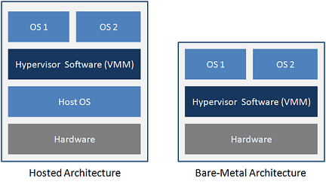

**Note: Operating systems has been installed on above Hypervisor by creating a Virtual machines.**

Virtualization Technology has been provided by below mentioned companies and along with their products.

|  |  |  |  |
| --- | --- | --- | --- |
| **S. No** | **Company Name** | **Hypervisor** | **Manage Hypervisor By using** |
| 1 | Vmware | Esxi | Vpshere Client, HTML5 |
| 2 | Citrix | Xen Server | XenCenter |
| 3 | Microsoft | Hyper V Core | Hyper V Manager |